Year-End Self Reflection
Having completed the Planning the Path Ahead ‘reverse career fair’ and thinking back throughout course experiences and assignments, draw on your experiences throughout the year to reflect on the following questions. Use examples and anecdotes from this years class and life experiences to support your statements.
Incorporate the themes of the big ideas into your responses. Each response should be authentic, insightful, and be 200-300 words.
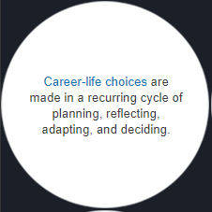
How did your plans for the future change between the plan ABC assignment at the start of the year and what you presented at the career fair? Why and how did you make those decisions? How might your plans change during grade 11 and 12?

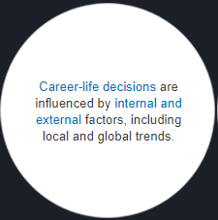
What internal and external factors influenced your proposed paths forwards? How did they guide your plans and decisions?

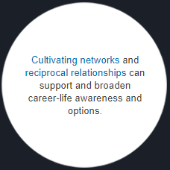
Describe a meaningful/impactful conversation that you had at the Plan the Path Ahead event. What did you learn? What do you think about their comments? Alternatively, if you did not have any meaningful conversations, what networks and relationships (who) can you connect with to support and broaden career-life awareness and options?

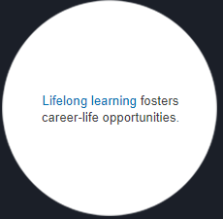
What learning activities or experiences will you pursue over the next one or two years? How could these help you personally or professionally develop? Think about school courses, sports, extra-curricular activities, volunteering, work, reading, hobbies, etc.

